PERSONAL PROFILE


Name: Lakshmi Sarvani Videla
Designation: Computer Science Lecturer
College Address: SRR & CVR GDC (A) Vijayawada
Cell No: 9985622936
Mail Id: lsv@srrcvr.ac.in

Educational Qualifications
S.NO | COURSE | BOARD / UNIVERSITY | YEAR OF PASS | PERCENTAGE
1 | SSC | AP BOARD | 1996 | 78
2 | INTERMEDIATE | AP BOARD | 1998 | 72
3 | B.Sc | MUMBAI UNIVERSITY | 2001 | 58
4 | MCA | IGNOU | 2010 | 74.34
5 | M. Tech (CSE) | JNTUK | 2014 | 94.45
6 | Ph. D | KLEF | pursuing

Professional Experience:
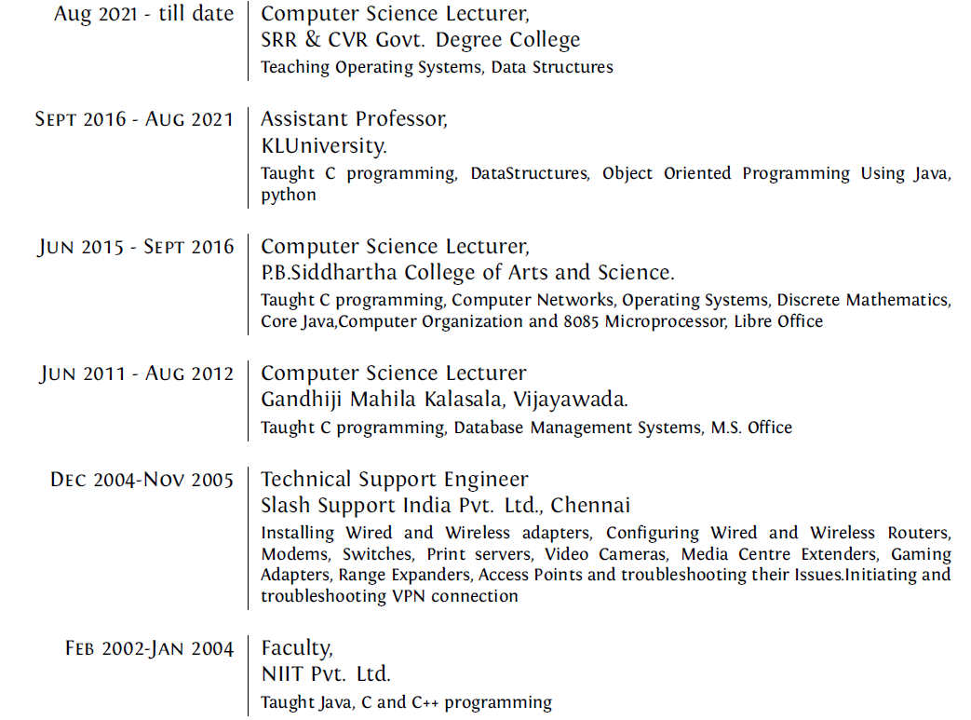
Achievements
- Qualified in GATE 2012 and APSET
- Completed the sanctioned Internal Funding Research Project Titled “Fatigue monitoring for drivers in image processing” in 2016-2017. Funded by KLEF.
- Received Best Teacher Award for the Academic year 2017-2018
- Conferred Best Paper Award for my paper “Facial Expression Classification Using Vanilla Convolution Neural Networks” in 7th IEEE International Virtual Conference on Smart Structures and System held on 23rd and 24th July,2020
- Received Certificate of Appreciation for getting Silver Medal in Coding Competition from KLEF on 17th February 2018
Memberships:
- Member in The Society of Digital Information and Wireless Communications with membership id 30661
- Member in International Association of Engineers with membership id 285113

In service programs attended: NIL
Research Experience : Article published:
- Revealing an OSELM based on traversal tree for higher energy adaptive control using an efficient solar box cooker,P Thamizharasu, S Shanmugan, S Sivakumar, Lakshmi Sarvani Videla,Solar Energy 218, 320-336
- Fatigue Monitoring for Drivers in Advanced Driver-Assistance System,LS Videla, PMA Kumar,Examining Fractal Image Processing and Analysis, 170-187,2019:
- Deformable facial fitting using active appearance model for emotion recognition,LS Videla, MRN Rao, D Anand, HD Vankayalapati, S Razia,Smart Intelligent Computing and Applications, 135-144
- Modified Feature Extraction Using Viola Jones Algorithm, LS Videla, PMA Kumar, Journal of Advanced Research in Dynamical and Control Systems 10 (3), 528-538
- Prediction Of Heart Disease Using Multiple Regression Analysis And Support Vector Machines, DN P.Siva Kumar, V.Sarvani, P.Prudhvi Raj ,K.Suma,Journal Of Advanced Research in Dynamical and Control Systems, 675
Conferences at International level:
- Review on Word2Vec Word Embedding Neural Net, S Sivakumar, LS Videla, TR Kumar, J Nagaraj, S Itnal, D Haritha,2020 International Conference on Smart Electronics and Communication (ICOSEC), 282-290
- Facial Expression Classification Using Vanilla Convolution Neural Network,LS Videla, PMA Kumar,2020 7th International Conference on Smart Structures and Systems (ICSSS), 1-5
- Murmured Speech Recognition Using Hidden Markov Model,R Kumar, LS Videla, S SivaKumar, AG Gupta, D Haritha, 2020 7th International Conference on Smart Structures and Systems (ICSSS)
Conferences at National level: NIL
Conferences at State Level: NIL
Workshops attended:
- Participated in Three days workshop on machine learning With scikit learn, keras and tensor flow conducted by Sri Rama Krishna Engineering college, coimbature during 17th – 19th May 2021
- Participated in workshop on “Designing IOT based applications to fight COVID-19 on 20th may 2020 organized by the Institute of Engineering and Technology
- Paticipated in international e-workshop on “Angular JS-Join & Learn to Develop Web Applications Faster on 26th June 2020 organized by Andhra Loyola institute of Engineering & Technology
Administrative Experience :
- Member in JKC
- Member in Admission committee
- Network In charge

